Project Development Phase
Model Performance Test

Date | 02 October, 2026
Team ID | SWTID-2026-3664
Project Name | Script-Controlled ACL – Restrict Record Access Based on Field Value
Maximum Marks | 10 Marks

Model Performance Testing:
Project team shall fill the following information in model performance testing template.
S.No. | Parameter | Values | Screenshot
 | Metrics | Authorized Access: Allowed  Unauthorized Access: Denied  Operations Tested: READ, CREATE, WRITE and DELETE | 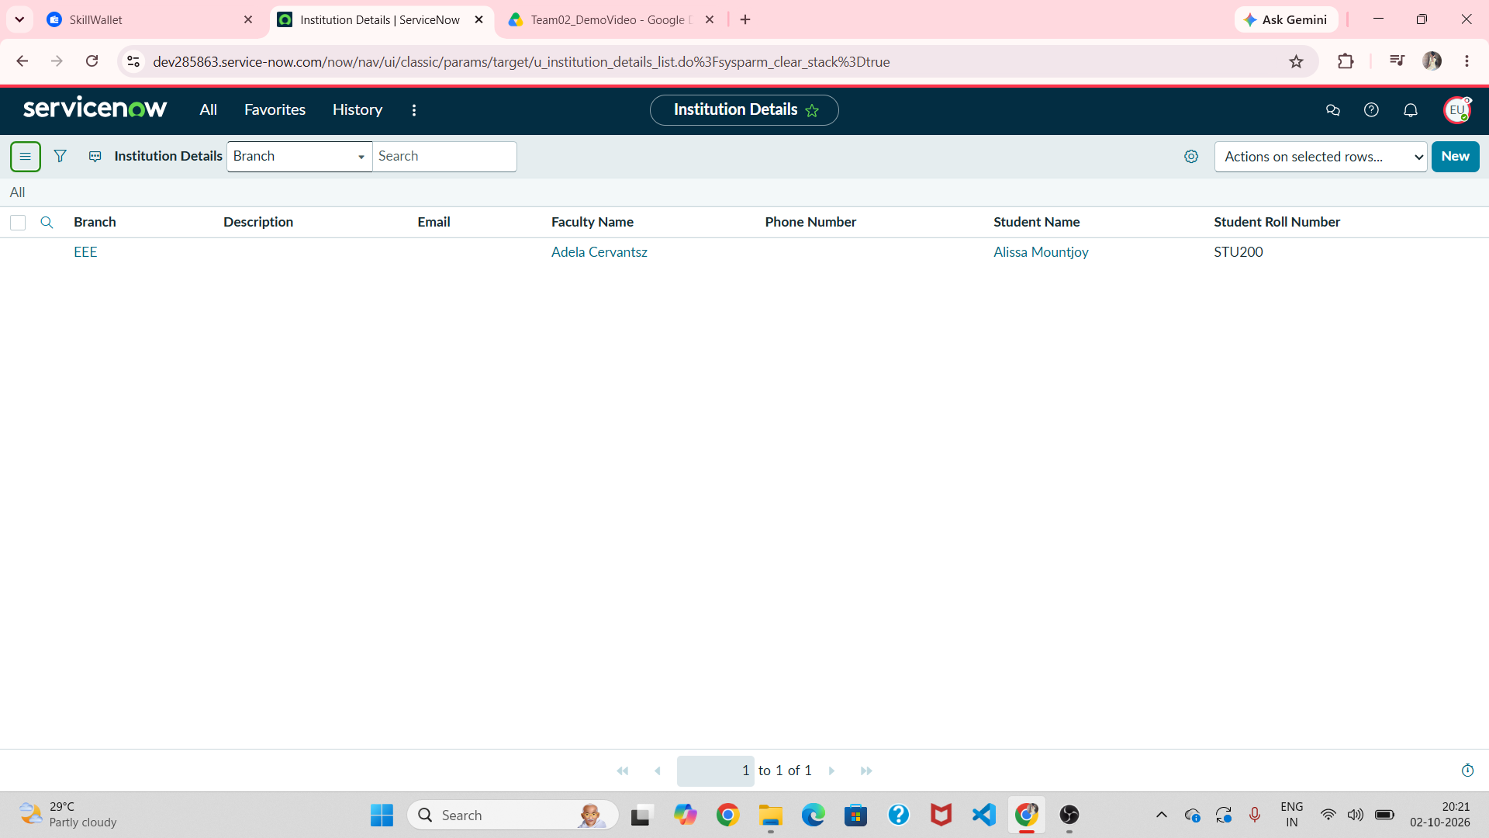
 | Tune the Model | Conditions: User role + record field value  Validation: ACL rules tested and refined for required access operations | 